Welcome to Brighton College Abu Dhabi

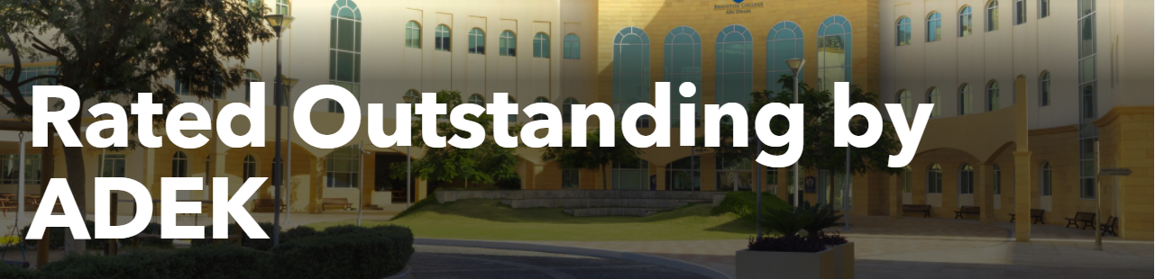

At Brighton College Abu Dhabi our aim is to ensure all pupils in our care are happy, confident, well-motivated and enthusiastic about life and learning. We aim to provide appropriate and balanced academic challenges for our pupils, to support each child to realise and reach his or her individual potential.
We strive to provide our pupils with exciting programmes of activities beyond the classroom, enabling them to strengthen their abilities and build character, as well as learning the value of trying something new and taking risks.
Brighton College Abu Dhabi is a purpose-built school set in its own grounds accommodating approx. 1830+ children and young adults. Pre-Prep is for Nursery age to Year 2 children with class sizes varying between 20-22 pupils. Our Prep School includes children from Year 3 to Year 6 with class sizes varying between 23-25 pupils and our Senior School includes young people from Year 7 to Year 13 with class sizes varying between 15-22 pupils.
All our staff are committed to providing our pupils with a safe, caring and supportive environment. BCAD’s community boast 73 nationalities including 25% UAE, 23% British, 7% Korean, 4% Canadian, 4% American, 4% Australian, as well as a rich variation of other nationalities from across the globe.
BCAD offer French, Spanish, German and Mandarin as language options from Yr 7. For non-Native speakers, Arabic language lessons are compulsory from Yr 2 until Yr 10, as well as a compulsory subject for native Arabic speakers from Yr 2 until Yr 13.
Our college missions and ethos are:
- To impart a love of learning with a foundation of knowledge and provide our pupils with skills to understand and question the world they live in, through an innovative approach to education.
- Develop an awareness and appreciation of different lives and dimensions in an international environment.
- To build within our pupils an enthusiasm for the world beyond the classroom, particularly in the areas of sport, music and the performing arts and to respect the differences in others with recognition that the efforts and achievements of every individual in our community, is valued equally.
We share our ethos with our sister schools Brighton College UK, Brighton College Dubai, Brighton College Al Ain, Brighton College Bangkok and now Brighton College Singapore. There are strong links at all levels amongst the Brighton College family of schools and we are proud to share that many of our pupils move on to further prestigious education institutions of which can be viewed here .

In short, we strive to turn out well-educated, respectful, and intellectually curious men and women who are ready to take a full, active and positive role in the life of their local, national and international communities.

Admissions Process

STEP 1 | Learn about Brighton College Abu Dhabi  - We invite you to watch our Headmistress - Mrs Wilkinson’s Virtual Open Day Introduction here, to learn more about BCAD.  - View our virtual campus tour here  - Listen to the parents and pupils’ feedback following our return to campus learning here  - View Uniform here  - View tuition fee’s here * see below  - We invite you to book a campus tour here
STEP 2 | To create an application, you will need to upload the following documents** see below:  - Child’s most recent school report (if yet attended for pre prep children)  - Child’s most recent Transfer Certificate. See example below.  - Child’s previous eSIS number (if coming from a school in Abu Dhabi)  - Child’s Immunisation/Vaccination record  - Father, Mother and Child’s clear coloured photo  - Father, Mother and Child’s passport copies  - Father, Mother and Child’s Visa, Emirates ID Front and back once received.  In the case of your child/ren’s documents still being processed, a child can start school, as long as one parent has their visa/Emirates ID and a ADEK undertaking has been sign at Admission stage. This is to agree that you as parents will share your child/ren’s documents with the school for ADEK registration, once received.
STEP 3 | Create an application here, if you are interested in your child joining our college.
STEP 4 | - Children applying to join Pre-Prep are required to submit video recordings of various requested activities or may be invited in for a play session based on Head of Schools request.  - Prep School applicants are to complete a CAT4 assessment and provide samples of schoolwork, as well as submit a 2-3mins video of your child reading. On occasions at the request of the Head of School, a Prep applicant may be asked to have an interview.  - Pupils applying for Senior school or 6th Form will sit a CAT4 test, a writing task and have an interview with the Head of school.  - What is a CAT4 Assessment: View here to learn more about the CAT4 assessment and here for an example.
STEP 5 | Applicants will receive an offer letter or be advised of a best next step.
STEP 6 | A BCAD Offer letter include the Admissions Handbook, informing you of how to accept and confirm your child’s seat, complete the mandatory ADEK registration (***see below) submit options for yr7 applicants upwards and uniform info etc.
STEP 7 | On completion of payment and eSIS registration, you will be issued a start date and class assignment email, welcoming your dear child to join our BCAD.

Useful Information 1
*
Fee Structure, Registration Deposit & Term Payment

SCHOOL | YEAR | TERM 1 | TERM 2 | TERM 3 | TOTAL |  | Registration Deposit
PRE-PREP | FS1 | 19,560 | 14,670 | 14,670 | 48,900 |  | 2,445
 | FS2 | 20,352 | 15,264 | 15,264 | 50,880 |  | 2,545
 | 1 | 24,096 | 18,072 | 18,072 | 60,240 |  | 3,010
 | 2 | 24,096 | 18,072 | 18,072 | 60,240 |  | 3,010
PREP | 3 | 24,096 | 18,072 | 18,072 | 60,240 |  | 3,010
 | 4 | 24,096 | 18,072 | 18,072 | 60,240 |  | 3,010
 | 5 | 24,096 | 18,072 | 18,072 | 60,240 |  | 3,010
 | 6 | 26,384 | 19,788 | 19,788 | 65,960 |  | 3,300
SENIOR | 7 | 26,384 | 19,788 | 19,788 | 65,960 |  | 3,300
 | 8 | 26,384 | 19,788 | 19,788 | 65,960 |  | 3,300
 | 9 | 26,384 | 19,788 | 19,788 | 65,960 |  | 3,300
 | 10 | 31,088 | 23,316 | 23,316 | 77,720 |  | 3,885
 | 11 | 31,088 | 23,316 | 23,316 | 77,720 |  | 3,885
 | 12 | 31,088 | 23,316 | 23,316 | 77,720 |  | 3,885
 | 13 | 31,088 | 23,316 | 23,316 | 77,720 |  | 3,885

To accept our offer, please complete the 5% registration deposit payment if you are enrolling your child prior to the start of the academic year. The 5% will be adjusted against the amount payable for your child’s total annual tuition fee.
If you are enrolling your child during the academic year, you will be required to pay for the remains of the term up front.
Payment can be made via bank transfer, cheque, or Credit/Debit Card.
A 2.5% discount is available to all parents completing a full year’s tuition fee payment. Currently there are no sibling discounts available.
Useful Information 2
**
Country and Region Document Attestation Guide

Attestation is the formal documentation recognition or authentication process. This is completed by the relevant government bodies: Ministry of Education or Ministry of Foreign Affairs and the UAE Embassy of the country overseas.

It is recommended that you make the attestation of the transfer certificate and final school report prior to relocating to Abu Dhabi. Please see the table below for the requirements relevant to you.

Country of Origin  [location of current school] | Attestation | Documents Required
Another school within Abu Dhabi | No | A copy of the final school report, signed and stamped by the current school.
Another Emirate of the UAE | No | Transfer certificate and last school report, signed and stamped by the school and the Ministry of Education in the current Emirate.
North America (except Quebec) Western Europe (including the UK) and Australia | No | Transfer certificate and school report, signed and stamped by the school.
South, Central America, Asia, Russia, Central Asia, Eastern Europe, Africa and New Zealand. | Yes | Transfer certificate and final school report, signed and stamped by the school and attested by the Ministry of Education or Ministry of Foreign Affairs and UAE Embassy in the country of origin.
GCC Countries | Yes | Transfer certificate and final school report card, signed and stamped by the school and attested by the Ministry of Education from the country of school origin.

Useful Information 3
***
What is ADEK eSIS registration?

All pupils in Abu Dhabi are required to be registered with ADEK – Abu Dhabi Department of Education of Knowledge, which is the government education body under the Ministry of Education. They are responsible for private schools in Abu Dhabi. To help monitor pupils within the Emirate, all schools and parents are legally required and are to ensure the registration of their children and young people on the ADEK Electronic School Information System (eSIS). This must be done before the first day of attending school.

School Day Timings

Year Group | Drop off | Drop off Location | Pick up | Pick up Location | Classes
Nursery | 7.30am – 7.45am | Pre-Prep Lobby | 1.50pm | Pre-Prep Lobby
FS2 | 7.30am – 7.45am | Pre-Prep Lobby | 1.55pm | Pre-Prep Lobby | Dugongs, Barracuda, Starfish
FS2 | 7.30am – 7.45am | Pre-Prep Lobby | 2.00pm | Pre-Prep Lobby | Whales, Jellyfish, Dolphins, Crabs
Year 1 | 7.30am – 7.45am | Pre-Prep Lobby | 3.00pm | Pre-Prep Lobby | Jerboa, Foxes, Caracals
 |  |  |  | Front Main Gate | Oryx, Gazelles, Hares, Flamingos
Year 2 | 7.30am – 7.45am | Pre-Prep Lobby | 3.00pm | Prep School Side Gate
Year 3 | 7.30am – 7.45am | Prep School Side Gate | 3.15pm | Prep School Side Gate
Year 4 | 7.30am – 7.45am | Prep School Side Gate | 3.30pm | Prep School Side Gate
Year 5 | 7.30am – 7.45am | Prep School Side Gate | 3.15pm | Prep School Side Gate
Year 6 | 7.30am – 7.45am | Prep School Side Gate | 3.30pm | Prep School Side Gate
Year 7-9 | 7.30am – 7.45am | Front main gate | 3.30pm | Front Main Gate
Year 10-13 | 7.30am – 7.45am | 7.30am – 7.45am | 3.30pm | Front Main Gate

School Bus Services and Routes

If you have any questions regards our School Bus Service, please feel welcome to contact our bussupervisor@brightoncollege.ae – Bus Supervisor: Ilyas Khan - 0508307277

Please do keep in mind, due to the current uncertainty surrounding Covid-19, all bus routes are subject to change depending on the demand for drop-off and pick up locations. Below are our current bus routes.
Nursery & FS2 Afternoon bus routes:
Route 1: All Reem Island Mina side | Route 2: Hamdan St, Electra St, Najda St, Al Falah, Al Nahyan
Brighton College | Brighton College
Marina Square, Al Reem Island | World Trade Centre Building
Hydra Avenue Tower, Al Reem Island Gate 4 | Al Safa Supermarket
Al Reem Island Sun Tower | Al Sama Tower
Al Reem Isalnd Gate Tower 1 | Al Bateen

Route 3: Mangrove Village, Mosque and Khalifa Park | Route 4: Al Bahia, Al Zeina, Al Muneera,
Brighton College | Brighton College
Bloom Garden | Al Zeina Block F
Khalifa Park Ministry Complex | Al Zeina Waitrose
Mangrove One Compound | Al Zeina Block C
Airport Road, behind Carrefour | Al Zeina Block B
Al Rihan Heights | Al Sana Al Muneera
Al Noor Hospital | Al Raha Gardens
Mangrove Village

General bus routes:

Route 1: Khalidiya | Route 2: Airport Road
Choitram Supermarket | Al Wahda EID Office
Abela Supermarket Building | Al Safa Supermarket
Al Safa Supermarket | UAE Exchange Hamdan
Khalidiya Village | WTC Building
Khalidiya Tower | Liwa St, DU Building
Spinneys Khalidiya | Khalifa Street
Al Khalidiya Towers B (Emirates Palace) | Al Nada Pharmacy
Al Bateen | British Embassy
Brighton College | Brighton College

Route 3: Al Reem island/ Salam St | Route 4: Hamdan St, Electra St, Najda St
Al Maya Tower | Beach Rotana
Gate Tower | Corniche Road
Hydra Tower | Khalifa St
Wave Tower | Salam St
Najmat Tower | Lifeline Hospital
Marina Square | Najda St Nissan showroom
Brighton College | Al Nayhan Compound
 | Eastern Mangroves Hotel
 | Brighton College

Route 5: Khalifa Park, Old Mushrif, Mushrif Mall | Route 6: Mangrove Village, Mosque, MBZ
American International School, airport road | Mangrove Village
Al Marjan Towers | Seashore Village
Guardian Tower | Rihan Heights Building
Mangrove One | Hills Abu Dhabi
Al Maqtaa Village | Brighton College
Al Seef Mall
Brighton College

Route 7: Al Raha Gardens, Al Forsan | Route 8: Al Bahia, Al Zeina, Al Muneera
Khalifa City A | Al Zeina- Waitrose
Al Raha Gardens (various) | Al Zeina Block
Al Forsan Village | Al Muneera Nadl
Al Forsan Village Spinneys Roundabout | Brighton College
Brighton College

Route 9: Al Reef Villas, Al Muneera, Khalifa Park
Al Reef Villas (various)
Al Muneera Sana
Al Muneera Raba
Ministry of Labour
Brighton College

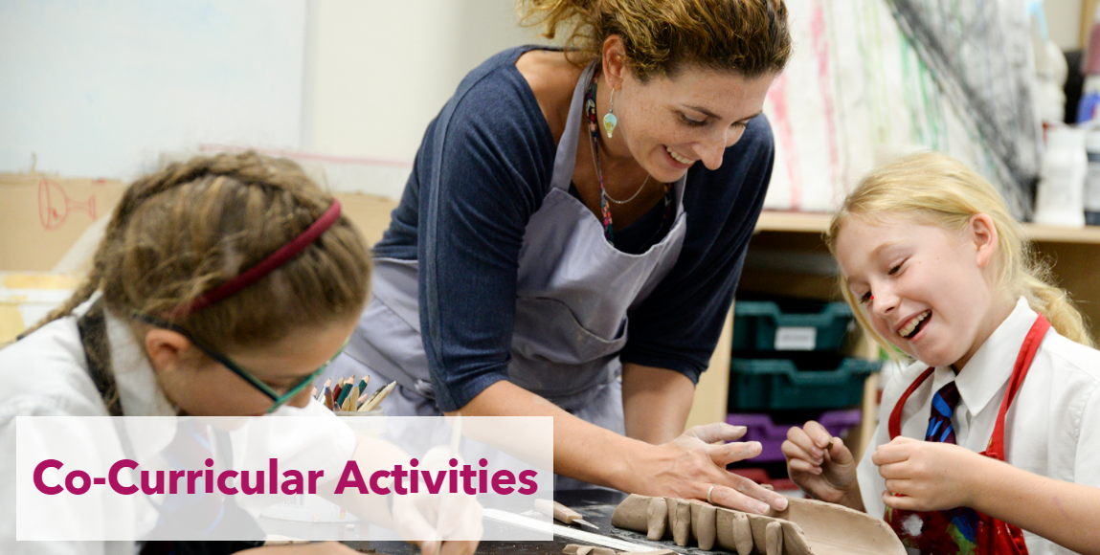

Name of CCA – Year 1

Spanish | Mindfulness Club | Art Club | Games Club | Drama | How to Draw Club | Fine Motor

Name of CCA – Year 2

Art Club | Origami Club | Mindfulness Club | Active Club | French Club | Coding Club

Parents in Nursery and FS2 do not select the club for their children. Co-curricular activities are selected by Teachers and are done during the school day.
Below are examples of the after-school activities available for Year 3 – 13. The selection of co-curricular activities are made at the beginning of each Term.
Please keep in mind there are no school bus services available after co-curricular activities. Parents must arrange travel to ensure their children arrive home safely.

Please note, that there are no CCA’s running during the month of Ramadan.

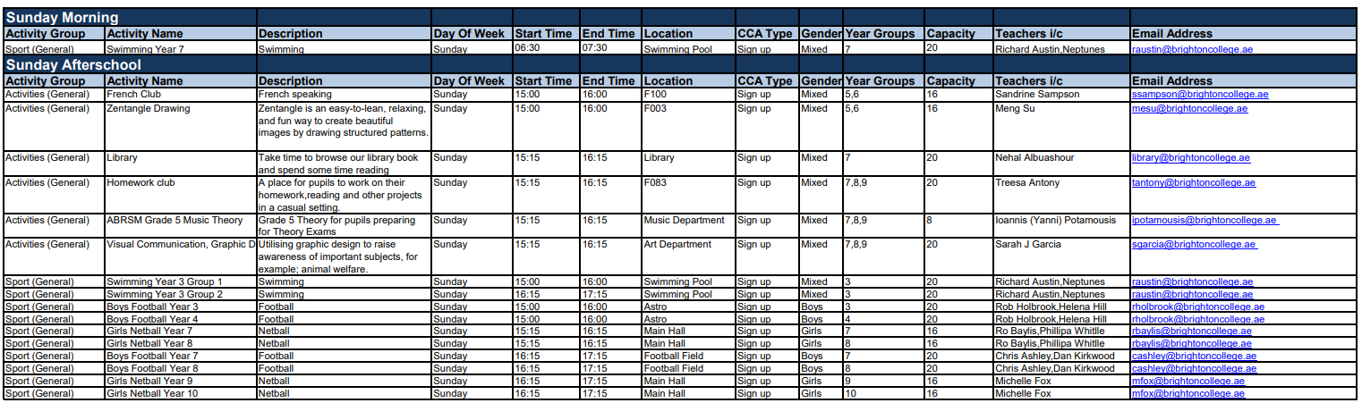

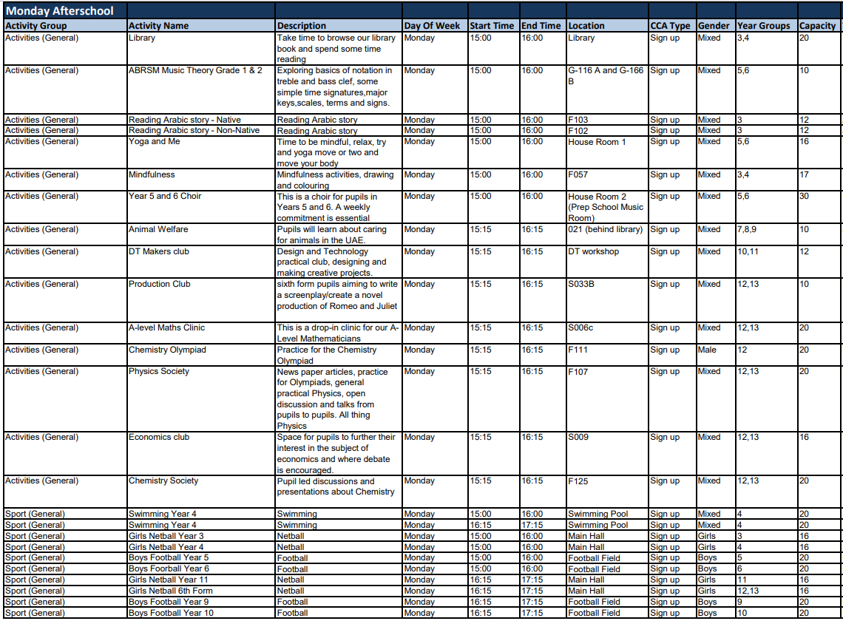
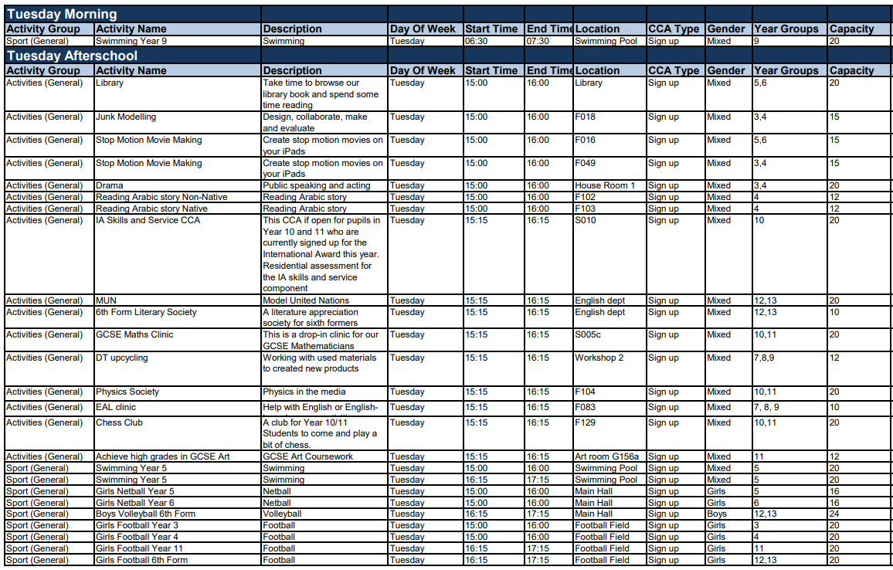
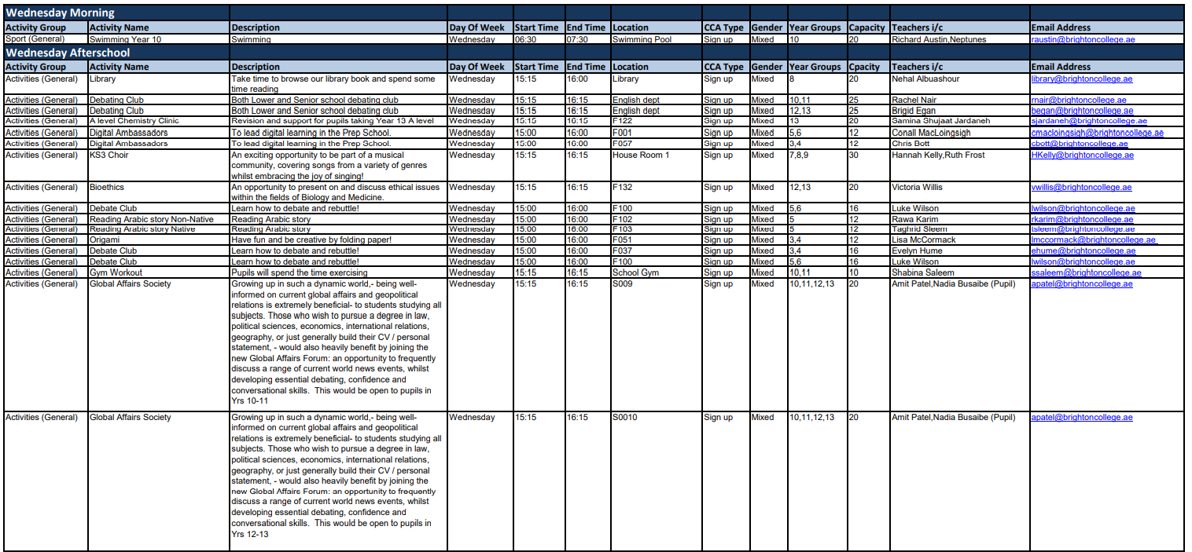
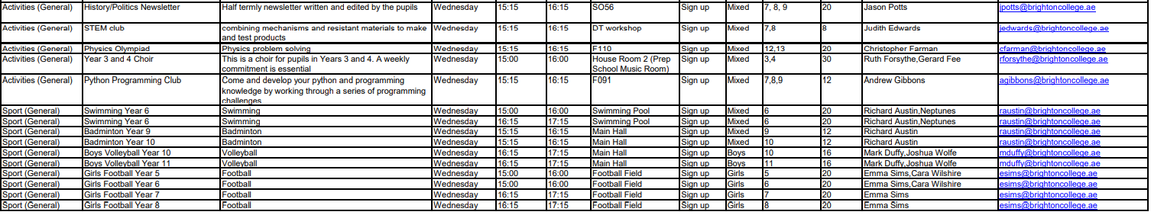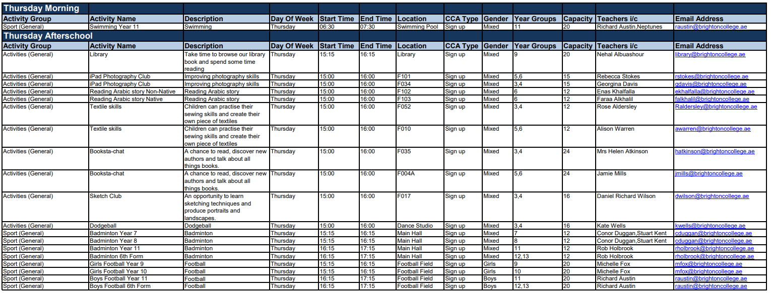

Example of Withdrawal Letter - Transferring from within UAE

DATE
To whom it may concern:

I can confirm that Name of Child – DOB - Nationality was enrolled on the Enrolment Date at Name of School, completing a xxx Curriculum at our school.
The last day of attendance was xxx.
Name of Child has completed Year/Grade xxx for the 2020/2021 Academic Year.
Name of Child is eligible for promotion to the next academic year.

SCHOOL STAMP

Yours sincerely,

Head Teacher/ Principal/ Director

Example of Withdrawal Letter - Transferring from outside of Abu Dhabi

Student Name:
Nationality:
Date of Birth:
Curriculum followed: (e.g., English, American, etc)
Date student was admitted to your school: (DD/MM/YEAR)
The year level that the student was first admitted to at your school: (e.g. Year 1): *
The student’s current Grade/ Year level: (e.g., Year 1) which is equivalent to year _____ in British Curriculum
The last date the student attended your school: (DD/MM/Year)
Results at the end of the academic year: (Please complete line 1,2 or 3 relevant to the pupil, then delete the lines not relevant.)

- Student will continue in Grade/ Year level ______ for the current academic year 20__to 20__which is equivalent to Year ____ in British Curriculum.

- Passed and promoted to Grade / Year level _____ for the new academic year ___which is equivalent to Year ____ in the British Curriculum.

- Detained in Grade / Year level ____ for the academic year ___ which is equivalent to Year ___ in British Curriculum.

School Stamp
Reason for leaving the school:

Observation:

Name:
Signature:
HEADMASTER/PRINICPAL/DIRECTOR

*If your school is following a different grading curriculum - please ensure that the current school indicates the equivalency to the 13-year British Curriculum.

For example: Grade 3…... is equivalent to Year 4 in the British Curriculum.

